Change <https://www.norwich.gov.uk/site/> to [https://www.norwich.gov.uk/jadu](https://www.norwich.gov.uk/jadu/)

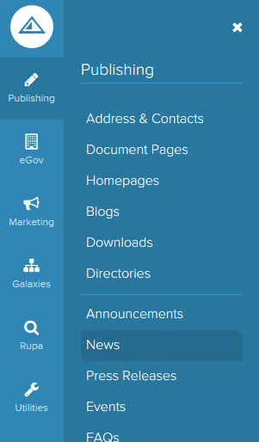

Click on publishing, then news

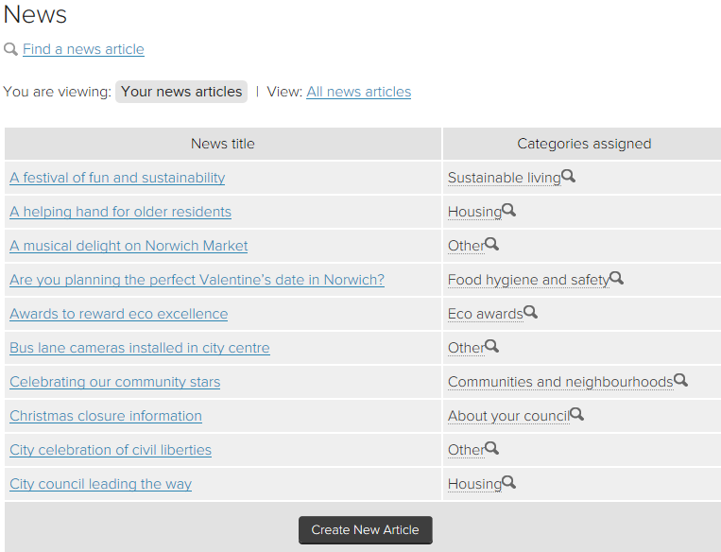

[Type a quote from the document or the summary of an interesting point. You can position the text box anywhere in the document. Use the Drawing Tools tab to change the formatting of the pull quote text box.]

Click on create new article

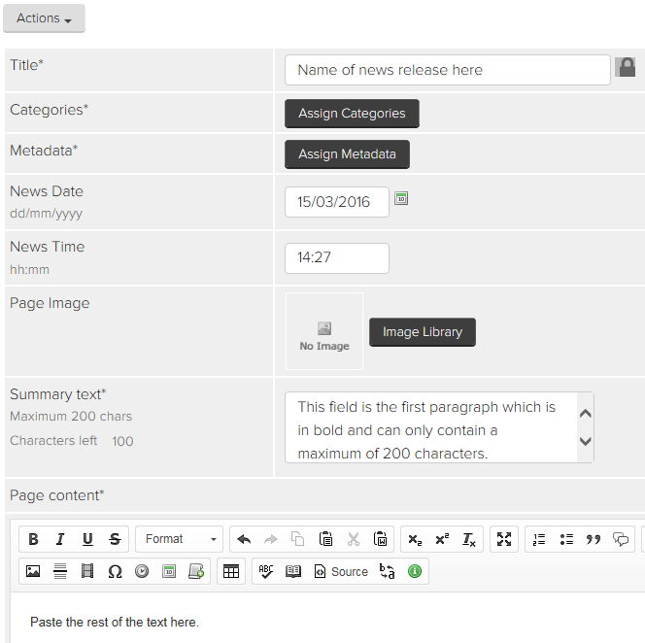

Click on assign categories and select one. Then click on the add and apply categories buttons.

Paste in the name of the news release

Click on assign metadata. In the description field paste in the news story title then click on assign metadata.

Paste in summary text

[Type a quote from the document or the summary of an interesting point. You can position the text box anywhere in the document. Use the Drawing Tools tab to change the formatting of the pull quote text box.]

Paste in the rest of the news story here.

Paste in the rest of the news story

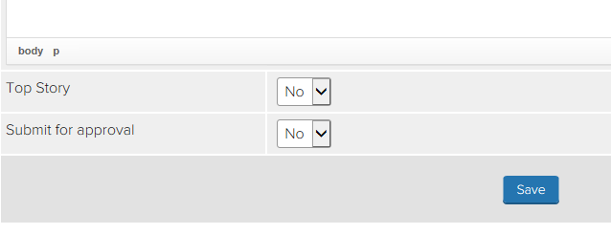

Select yes for top story and yes for submit for approval. Click on save.

To view the news article before it goes live click on actions, then preview. To make it live or to make any changes, you need to get click back into JADU. You should be taken to the news article you are creating.

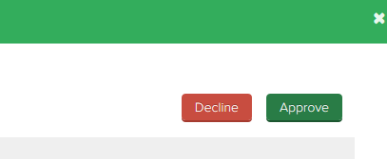

If you don’t want to make changes, click on approve.

If you do make changes, save and preview again.

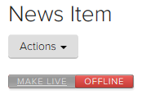

Click on make live

On actions click view live to see it.



If you want to edit any information in a news article that is already live, go back to JADU. Click on publishing, news and all of your news articles will be displayed. If you want to see somebody else’s news article select all news articles.

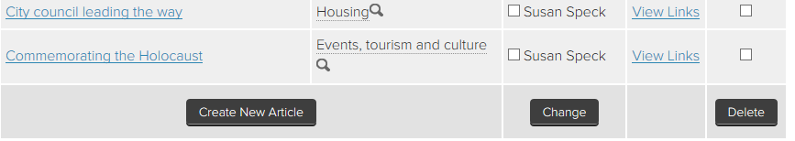

To edit, click on the news title.

To delete one, make your selection using the boxes on the right and click on delete.

To edit one just click on its title. To delete one