**Online forms: ~~CCTV Section 35~~ Section 35 request for CCTV footage (for legal professionals)**

We hold CCTV images for 28 days until they are automatically deleted. ~~by our system~~.

Use this form to submit a request ~~This form is for completion where CCTV footage is requested~~ under the Data Protection Act 1998, chapter 29 section 35 (2), which states:

Personal data is exempt from non-disclosure provisions where the disclosure is necessary;

1. for the purpose of, or in connection with, any legal proceedings ( including prospective legal proceedings) or,
2. for the purposes of obtaining legal advice,

or is otherwise necessary for the purposes of establishing, exercising or defending legal rights.

~~You will need the following to hand when you are completing this form:~~

When you complete the form you will need:

* full details of the incident, including date, time and specific location
* your reference number eg crime or court number
* ~~a payment card.~~ credit or debit card

There is a non-refundable fee of £10 for each request. ~~search~~. ~~which you can pay by credit card or debit card.~~

What is the response time?

When there is footage, how do we ask them to complete the other form?

If we do hold footage a further payment of £65 will be required to process and release the data.

Please see our main CCTV page for further information – Do we need to direct people back to these pages?

**CCTV footage details**

An error message came up without any description of the error when I added in a date that was more than 28 days:

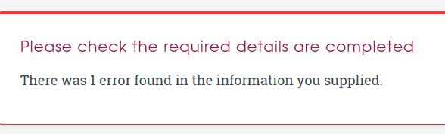

**Your reference number**

Spelling error - change to: reference

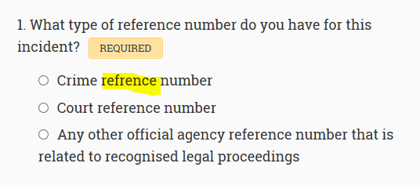

**Details of company requesting data access**

Text size here is smaller than other pages

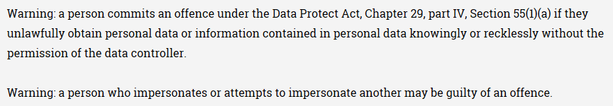

3. There is no page to supply address if the address not found option is chosen from the drop-down:

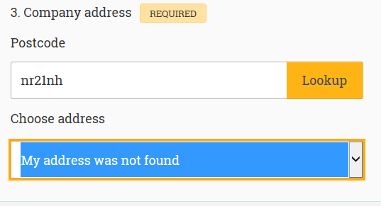

5. Add eg 0123456789

**Declaration**

What is the asterisk for at the end of the declaration?

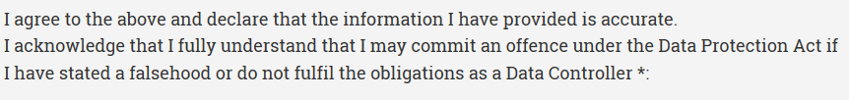

**Payment for CCTV footage (Section 35)**

Please only complete this form if we have asked you to ~~do so~~ following confirmation from us that we hold the footage you require a copy of, under ~~Chapter 29, Section 35 (2) of~~ the Data Protection Act 1998. ~~which states:~~

~~Personal data is exempt from non-disclosure provisions where the disclosure is necessary;~~

1. ~~for the purpose of, or in connection with, any legal proceedings ( including prospective legal proceedings) or,~~
2. ~~for the purposes of obtaining legal advice,~~

~~or is otherwise necessary for the purposes of establishing, exercising or defending legal rights.~~

When you complete the form you will need:

~~You will need the following to hand when you are completing this form:~~

* your reference number
* debit or credit card for payment of £65

When this additional payment has been received you will be sent a copy of the footage by recorded delivery within 15 working days.

**Details of company requesting footage**

3. There is no page to supply address if the address not found option is chosen from the drop-down:



5. There is no validation on the phone number, so anything in this field is accepted

Then add eg 0123456789

**Declaration**

What is the asterisk for at the end?

Can you close up the gap?

