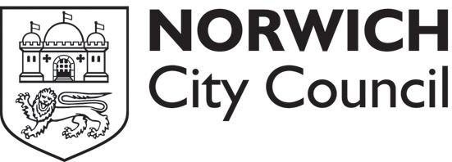

Business dispensations application form
Issuance policy
Up to 20 single dispensations or four books of dispensations may be purchased per company in any seven-day period. It may be possible to increase this amount in exceptional circumstances.

All new applications must include one of the below as relevant evidence. Copies are accepted. Follow-up applications do not require evidence but it will be required for later applications.
- a signed permit request letter on headed company or sole trader note paper
- proof of VAT number
- work order showing the location of work
- company or sole trader cheque or company debit card
- purchase order from the company.

Your details
Company name:
Contact name:
Address where dispensations will be sent:

City:
Postcode:
Telephone number:
Prices from June 21 2011:
- £5 for a single dispensation
- £20 for a book of five dispensations
Payment is by cheque only for postal applications
Send the application form and cheque, made payable to:
Norwich City Council, to Norwich City Council’s general administration support team at City Hall. St Peters Street, Norwich, NR2 1NH
Contacts
t: 0344 980 3333, lines are open from 8am - 5pm, Monday to Friday
e: info@norwich.gov.uk

