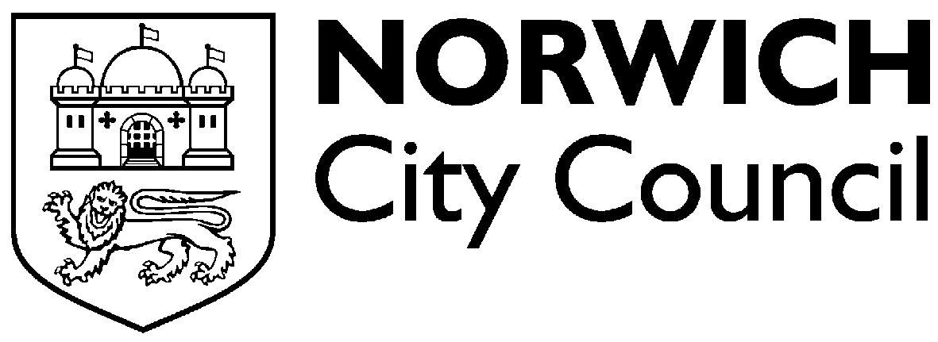

Application for renewal of

Norwich City Council driver's licence

I hereby apply for renewal of a hackney carriage driver's licence. My current licence expires on

Such licence to be subject to all the conditions and regulations imposed upon hackney carriage and private hire vehicle drivers either by statute, or by the byelaws made by Norwich City Council, for regulating such drivers.

Date

Surname

All first names

Address

Post Code

Age Date of birth Telephone number

Number of badge

To be completed by drivers working in the private hire trade:

Name of operator

Address of operator

To be completed by hackney carriage drivers:

Name of proprietor

Address of proprietor

Are there any prosecutions pending against you? If YES please give details.

If NO prosecutions enter NIL.

Alleged offence Date of court hearing

Have you had any convictions or formal cautions recorded against you since you last applied for a Norwich City Council driver's licence?

If YES please give details (all convictions and cautions must be declared-motoring and criminal). If NO convictions or cautions enter NIL.

Date of conviction/caution Offence Sentence including
fixed penalty
motoring offences
and suspended
sentences.

I declare that I have checked the information given on this form and to the best of my knowledge and belief it is true.
(The maximum penalty for making a false declaration or omitting a material particular is a fine not exceeding level 3 on the standard scale).

I also declare that I have received a copy of the byelaws, regulations and conditions applicable to hackney carriage and private hire vehicle, proprietors, drivers and operators.

Date Signed

