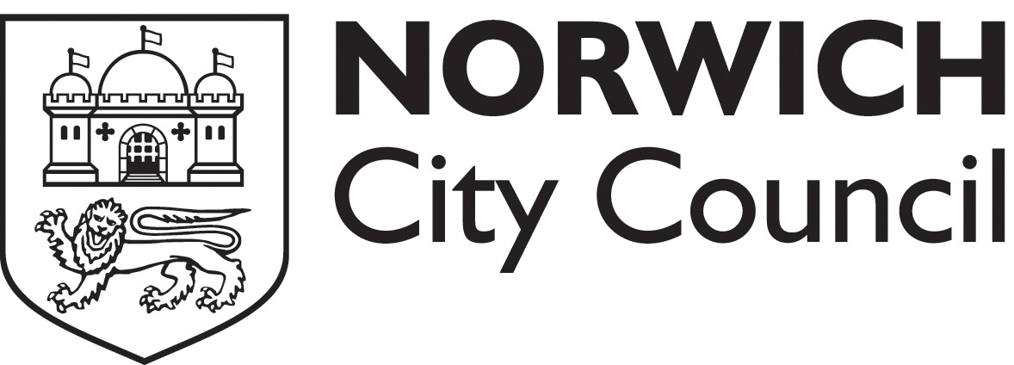
Safer Food Better Business Workshop

Safer Food Better Business is published by the Food Standards Agency and is recommended by Norwich City Council for most food businesses. If correctly implemented and used the pack should fulfil the legal requirement for a documented food safety management system.

This introductory course is designed for the person who is implementing the pack – normally the food business operator or the head chef, but is also of use to any staff members who are going to use the pack.

The course fee is £25.00 per person and includes refreshments and one SFBB pack per business (when available). All candidates will receive a certificate of attendance.

The courses will all run for 3 hours and be held in the Mancroft Room at City Hall Norwich.

Full Name | Position | Contact number
Business name

Business address

Business type
Course date
for dates see over page
Pay by Cheque:
I enclose a cheque for £ (£25 per person) made payable to “Norwich City Council”

Pay by Card:
REQUEST A CALL BACK and post / email the form in and we will call and take the payment over the phone (for call back enter the phone number to use here: )

Return the form by post/ email to:
Food & safety team, Norwich City Council, City Hall., St Peters St, Norwich, NR2 1NH
foodandsafetyteam@norwich.gov.uk 01603 212747

Total number of candidates: Total amount due: : N
Please note that refunds will not be made for requests to cancel course attendance, change dates or non- attendance. We reserve the right to cancel courses and in this case will offer refunds or an alternative date.

FOR OFFICE USE ONLY:
Credit Account | EHGNBC
Receipt Number:
CCT/ GAST please send form to Food and Safety Team
Safer Food Better Business Workshops:

Wednesday 24 February 2016

Wednesday 25 May 2016

Wednesday 6 July 2016

Wednesday 5 October 2016

Wednesday 14 December 2016

