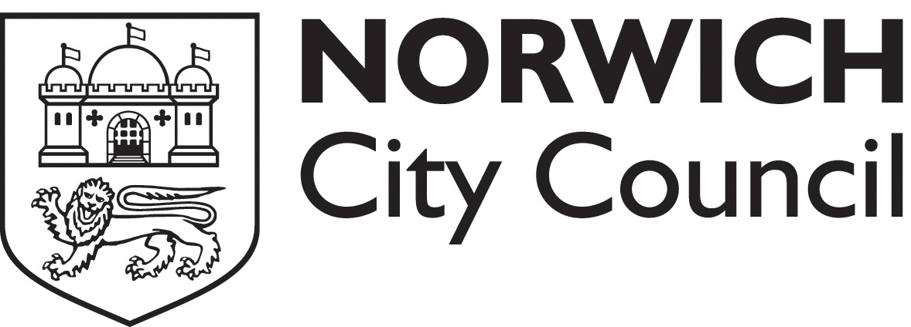
CIEH Level 2 Award in Principles of HACCP

This course is designed for all persons working with open or wrapped food products.

The courses will all run from 9.30am – 5pm and be held in the Mancroft Room at City Hall Norwich.

Syllabus materials will be covered during the day, concluding with an examination, the examination is multiple-choice, there are 30 questions and the pass rate is 20 out of 30. All those who successfully complete the examination will receive a certificate from CIEH.

The course will cover the following topics:
Food law; food safety hazards; taking temperatures; cooking, hot holding and re-heating foods; food handlers; principles of food storage; delivery and storage; cleaning; food premises and equipment.

The course fee is £60.00 per person and includes a course workbook, examination registration fee and refreshments but not lunch. Please note you must bring photographic ID with you.

Full name of candidate(s)
Position
Contact phone number
Business name

Business address

Course date
Do you have any special requirements?
Pay by Cheque:
I enclose a cheque for £ (£60 per person) made payable to “Norwich City Council”
Pay by Card:
REQUEST A CALL BACK and post / email the form in and we will call you and take the payment over the phone (for call back enter the phone number to use here: )
Return the form by post/ email to:
Food & safety team, Norwich City Council, City Hall, St Peters St, Norwich, NR2 1NH
foodandsafetyteam@norwich.gov.uk 01603 212747

Total number of candidates: Total amount due: N

Please note that refunds will not be made for requests to cancel course attendance, change dates or non- attendance. We reserve the right to cancel courses and in this case will offer refunds or an alternative date.

