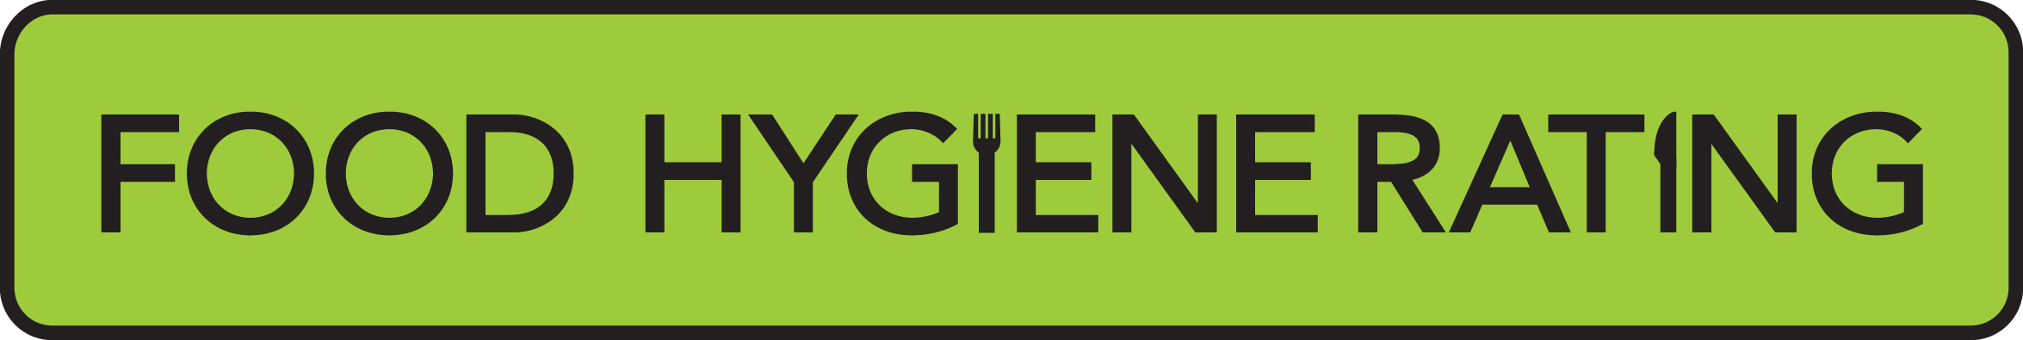 | Food hygiene rating scheme appeal form | 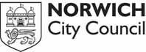

Notes for businesses
- As the food business operator of the establishment, you have a right to appeal the food hygiene rating given following your inspection if you do not agree that the rating reflects the hygiene standards and management controls found at the time of the inspection.
- You have 14 days (including weekends and bank holidays) from the date of receipt of the notification letter to lodge an appeal.
- Please use the form below and return it to the food safety team manager at Norwich City Council. Contact details are provided below.
- The food safety team manager will review your rating and communicate the outcome of your appeal to you within seven days of receipt.

 | Food business operator/proprietor:
 | Business name:
 | Business addresses:
 | Business tel no: |  |  |  |  |  |  |  |  |  |  |  |  | Business email:
 | Date of inspection: |  |  |  |  |  |  |  |  |  |  |  |  |  | Food hygiene rating given
 | Date notified of rating:

I do not agree with the food hygiene rating given by the food safety officer because:
(Please explain below under each of the three headings.)

Compliance with food hygiene and safety procedures
Compliance with structural requirements
Confidence in management/control procedures

 | Signed:
 | Name in capitals:
 | Position: |  |  |  |  |  |  |  | Date:

Please print off and return this form to:
Food safety team manager, Norwich City Council, City Hall, St Peters Street, Norwich NR2 1NH

