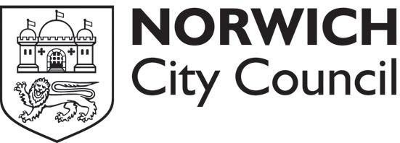

Data Subject Access Application Form

Under the terms of the Data Protection Act 1998, an individual is entitled to ask the Council for the personal information it holds about him/her.

PERSONAL DETAILS:

Full Name:

Address: Postcode:

Telephone No:

Date of Birth:

National Insurance No:

Data Subject Declaration
In exercise of the right granted to me under the terms of the Data Protection Act 1998, I request that you provide me with access to the personal data held about me.

I confirm that I am the above named individual.

Signed Date

There is a £10 fee for a Data Subject Access Request. Please make the cheque payable to Norwich City Council.

Please return the completed form to Norwich City Council, City Hall, Norwich, NR2 1NH

