Norwich City Council Licensing Authority  Licensing Act 2003 | 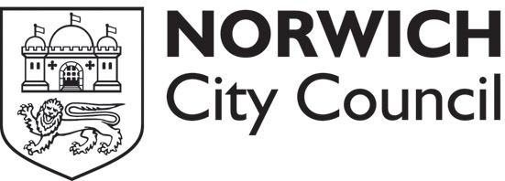
Statement of support or objection to an application
for a premises licence

Your name/organisation name/name of body you represent (see note 1)
Postal address
Email address
Contact telephone number
Address of the premises you wish to support or object to

Your support or objection must relate to one of the four licensing objectives (see note 2)
Licensing objective |  | Please set out your support or objections below.  Please use separate sheets if necessary.
To prevent crime and disorder

Public safety
To prevent public nuisance
To protect children from harm
Please suggest any conditions which would alleviate your concerns

Signed: |  |  |  | Date:
Notes

1. In order for you to be able to support or object to an application for a premises licence you must live, work or represent a body that is in the vicinity of the premises.

2. Comments of support or objection must relate to the four licensing objectives, which are:

- to prevent crime and disorder
- public safety
- to prevent public nuisance
- to protect children from harm.

3. An application for a premises licence will be notified to residents by displaying it on the premises and in the local press. Comments in support or objections must be made within 28 days of the date given in the public notice.

4. If you have made valid comments of support or objection you will be expected to attend a meeting of the authority’s licensing sub-committee and any subsequent appeal proceeding. If you do not attend, the sub-committee will still consider your comments, but they may not carry the same weight as if you had attended if, for example, the contents are disputed or challenged.

5. Your comments of support or objection will be passed to the applicant to allow them the opportunity to address your concerns in line with the Licensing Act 2003. Your comments will also be published in the report to the licensing sub-committee, which is publicly available and displayed on the city council’s website.

6. Please return this form when completed to:

Norwich City Council
Licensing section
City Hall
St Peter Street
Norwich
NR2 1NH
t: 01603 212761
f: 01603 212040
e: licensing@norwich.gov.uk

