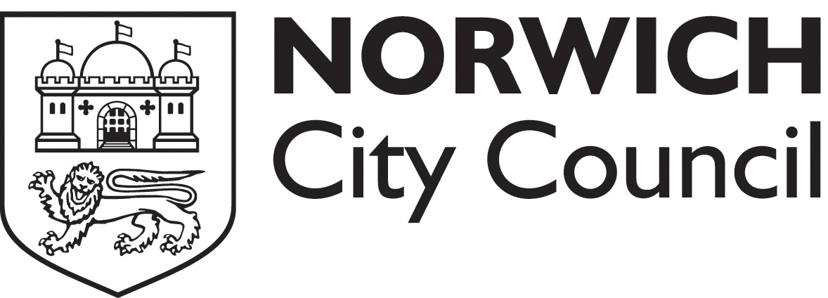

Improve Your Hygiene Rating Workshop
All catering and retailers in Norwich are now being given a national food hygiene rating. Businesses that are given a rating of less than three must take urgent steps to improve.
This workshop is designed to help businesses understand how to achieve a higher rating.
The workshop lasts two and a half hours and covers the structural requirements for a food business; cleaning practices; personal hygiene; temperature control; cross contamination; cooking; pest control; food safety management requirements and documentation; food hygiene training requirements. During the workshop there will be a handwashing demonstration. If you have a documented food safety management system (such as Safer Food Better Business) please bring this along with you.
At the end of the workshop attendees will have a thorough knowledge of what the national food hygiene rating scheme is, how their hygiene rating is calculated, avoid the traps that make for a bad rating and understand what they must do to improve their rating and keep it high in the future.
Workshop dates
All workshops take place on a Tuesday from 1.30pm to 4.30pm in the Mancroft Room at City Hall.

Please book place(s)

Name: | Position: | Contact number:
Business name:

Business address:

Business type:

Workshop date:

I enclose a cheque for £ (£45 per business and two trainees may attend; further trainees may attend at £45 for each additional two) made payable to “Norwich City Council”
send to: Mr Chris Gooding, Food safety team, City Hall, St Peters Street, Norwich NR2 1NH
Please note

- Full payment must be received by the date given for each course.
- We reserve the right to cancel the training session and offer a full refund.
- A business may substitute a trainee.
- A training certificate will be issued in the name of the attendee.

