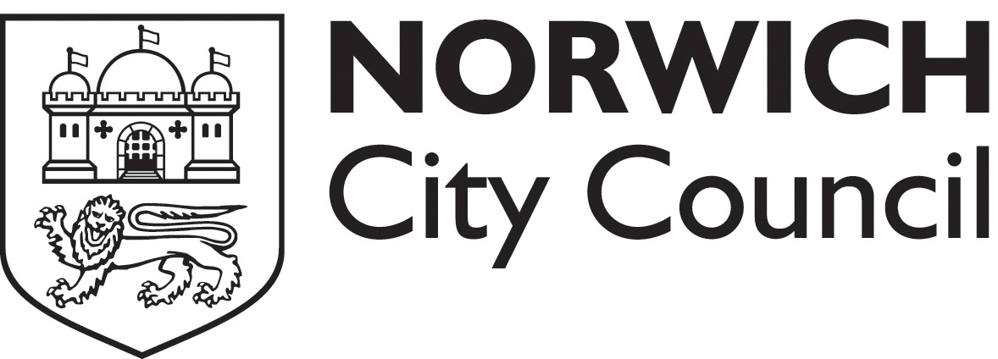
Safer food better business workshop

Safer Food Better Business is published by the Food Standards Agency and is recommended by Norwich City Council for most food businesses. If correctly implemented and used the pack should fulfil the legal requirement for a documented food safety management system.

This introductory course is designed for the person who is implementing the pack – normally the food business operator or the head chef, but is also of use to any staff members who are going to use the pack and will also serve as a food hygiene refresher course. The course will last for about three hours.

Booking dates

Names will be added to the waiting list for the next SFBB workshop, we will then organize a workshop and get back to you to confirm the details.

All workshops usually take place in the Mancroft Room at City Hall, Norwich at 1.30pm.

Please book place(s)

Name | Position | Contact number
Business name

Business address

Business type
Workshop date

I enclose a cheque for £ (£25 per person) made payable to “Norwich City Council” and send to:
Mr Chris Gooding, Food safety team, City Hall, St Peters Street, Norwich NR2 1NH.
Please note:

- Full payment must be received by the date for each course.
- We reserve the right to cancel the training session and offer a full refund.
- Cancellations will be accepted
- A business may substitute a trainee.
- A training certificate will be issued in the name of the attendee.
- Attending the workshop will enable the attendee to demonstrate that they have received food hygiene refresher training.

